Ajay Jayaram won Dutch Open - 2014
New Delhi, October 14, 2014 |

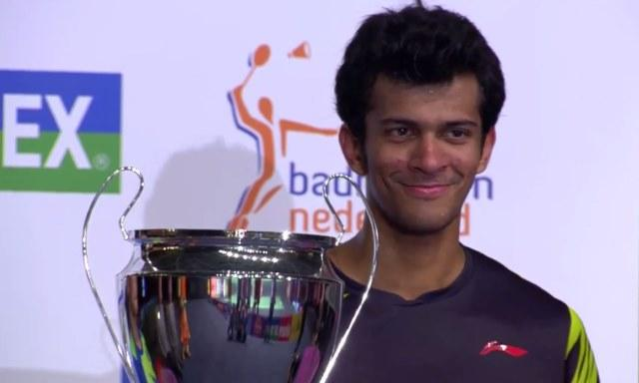
New Delhi: It was grit and determination on which Ajay Jayaram rode on to return to the International Circuit in style. He clinched the USD 50,000 Dutch Open Grand Prix Badminton Title, his biggest career achievement, and after returning from a seven-month injury lay-off. Jayaram, seeded 13th, rallied to beat unseeded Indonesian Ihsan Maulana Mustofa 10-11, 11-6, 11-7, 1-11, 11-9 in the final at Almere, played under the new 11x5 scoring system.
Jayaram had beaten top seed Rajiv Ouseph of England 11-8 11-7 11-5 in a 26-minute Semi-Final to enter Title round. Jayaram got past Chun Hei Tam of Hong Kong in the Pre-Quarterfinals and third-seeded Indonesian Dionysius Hayom Rumbaka in the Quarter-finals.
A shoulder injury during the Hong Kong Open in January this year put him out of action for more than six months. Jayaram underwent a surgery and did the necessary rehabilitation. But at only his fourth tournament back, the Mumbai shuttler won the biggest event of his career when he clinched the Dutch Open Grand Prix on Sunday.
"Definitely it has surprised me. I played some good attacking Badminton. I need to maintain this level of focus and discipline in the coming tournaments. That will be the key to getting good results," Jayaram told MAIL TODAY.
Ajay Jayaram wins the Dutch Open. The manner of his win, coming against a tough field, should give Jayaram immense confidence. Beating the likes of third seed Dionysius Hayom Rumbaka (World No. 26) of Indonesia and top seed Rajiv Ouseph (World No. 29) of England would do him a world of good.
"With higher-ranked players like Ouseph and Rumbaka in my half, it wasn't going to be easy. I secured convincing wins against both. The final was against an upcoming Indonesian (Ihsan Maulana Mustofa). It was a hard fought five-game battle which swung both ways. I had to dig deep and bring all my focus into play in the fifth game where I was 1-5 down. But I played well and was positive when it mattered."
Now Jayaram has got a feel of the new scoring system that is being introduced at the Grand Prix level on an experimental basis. "Although the game gets shorter, most of the match is played under more pressure which requires more focus. Hard to say if it is the way to go for Badminton, but I'm glad I was able to adjust to it and do well."
Jayaram was ranked as high as 21st in early 2013. Getting back to the National Team is his priority. "If I am able to maintain the same positive tempo, I'm sure I will regain my place in the core group," he said.
Jayaram’s Coach Tom John said the win would help his ward return to the top on the Men’s circuit. “It was a difficult past few months to get him ready. We had to change his training routine and make him work harder. The win has boosted his confidence,” John said.
-------------------------------------

